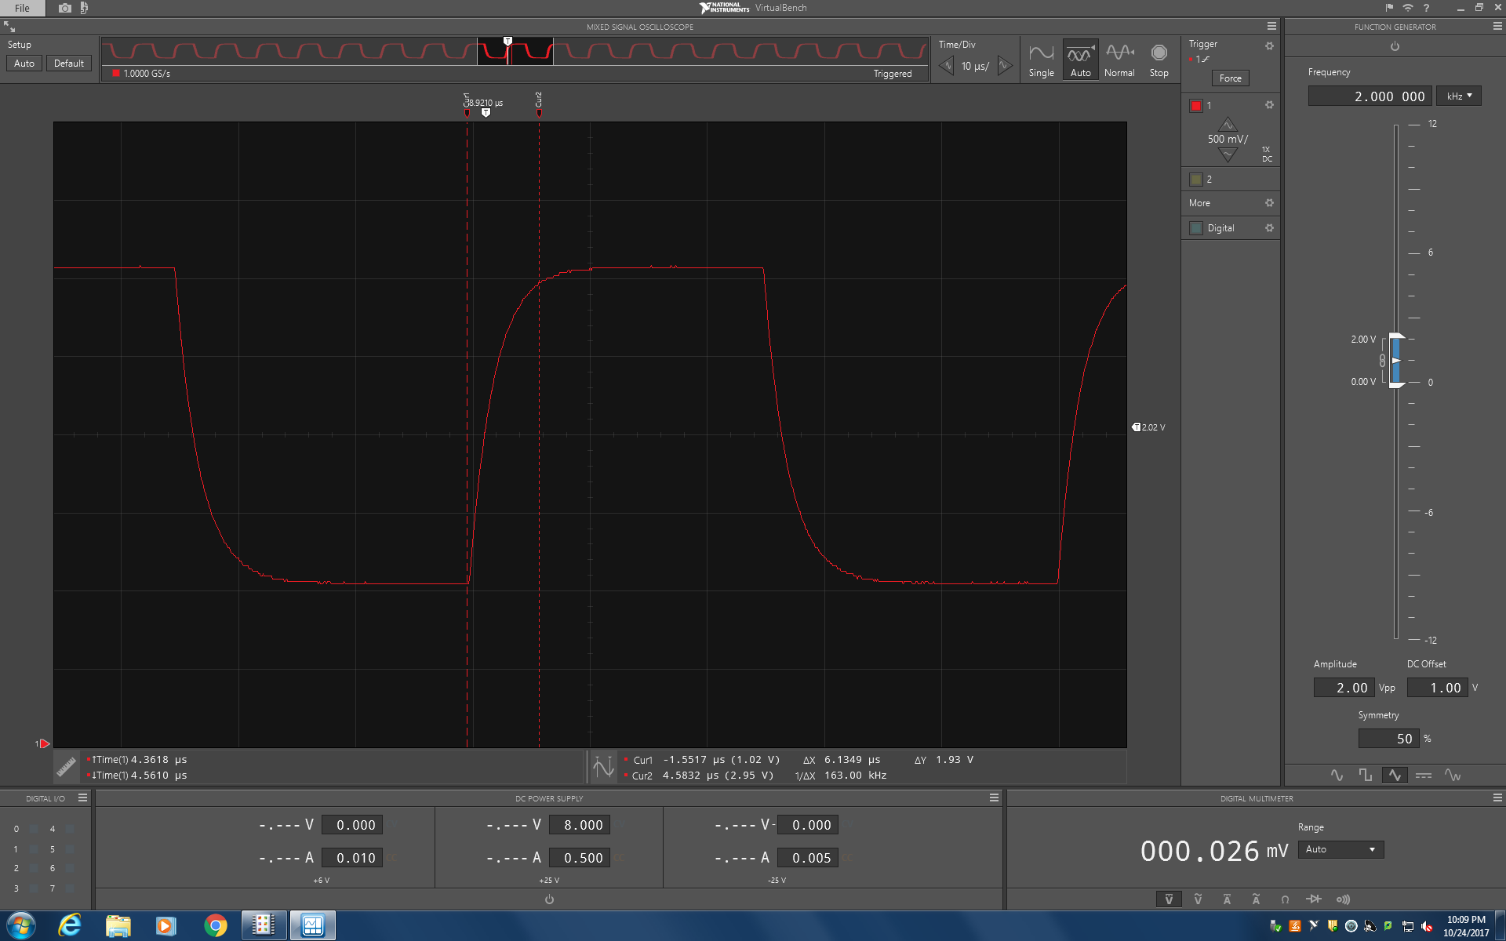

**Figure 2a.** Rising edge scope trace of waveform.

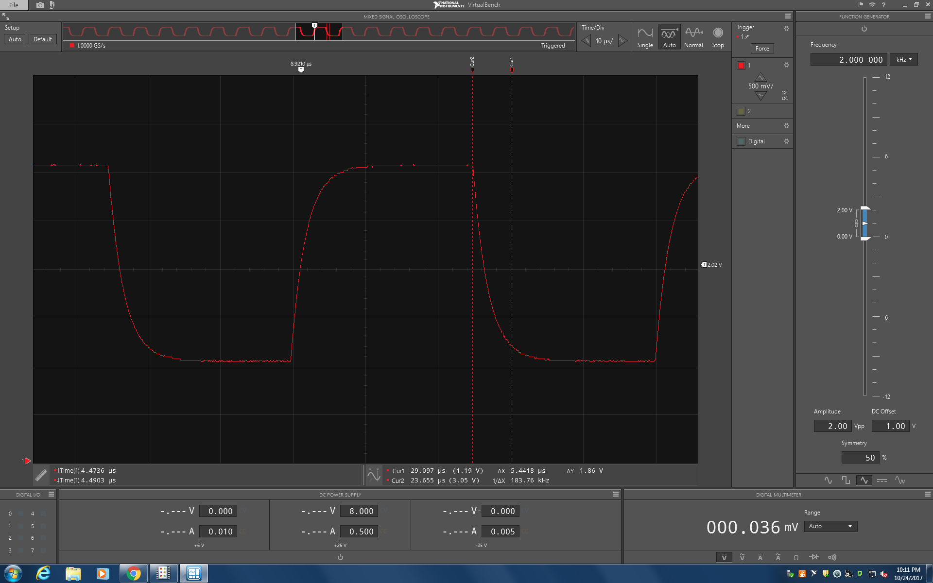

**Figure 2b.** Falling edge scope trace of waveform.